
NATIONAL INSTITUTE OF TECHNOLOGY DURGAPUR
INDIA

CURRICULUM VITAE

Name of the Industry/Organisation: Amazon
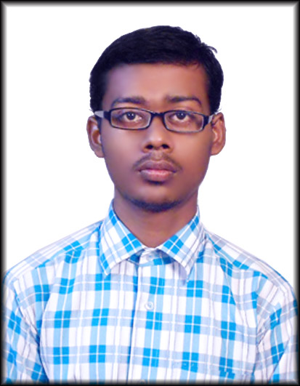
- GENERAL

Affix
Photograph
  - Name: Abhishek Prasad

Date of Birth: 7th May 1997

Father’s/Mother’s Name: Shiw Shankar Prasad

Roll No: 15/IT/31 Branch: Information Technology

Height: 175 cms Weight: 62 kg
Power of Glasses L -0.75 R -1.25

Present Address: Vill - Pursha

P.O. - Durgapur – 7
District – Burdwan(West Bengal)

Address for Correspondence: Hall – 3, Room – 301, NIT Durgapur

E-Mail Id: prasadabhishekdgp@gmail.com Cell No: +917602867497

2. EDUCATIONAL QUALIFICATIONS
2.1 Secondary & Higher Secondary
Examination | Board / Institution | Year of Passing | Marks
Examination | Board / Institution | Year of Passing | Obtained | Out of (Total) | %
10th Std | C.B.S.E | 2013 | 9 | 10 | 85.5
12th Std | A.I.S.S.E | 2015 | 89.2 | 100 | 89.2

2.2 Under Graduation
SEM | 1 | 2 | 3 | 4 | 5 | 6 | 7 | 8
SGPA | 6.67 | 7.89 | 6.9 | 7.34
CGPA | 6.67 | 7.28 | 7.15 | 7.22

3. PERSONAL PROJECTS
- A drawing board kind of program for making pictures in text mode using graphical characters for the DOSBOX platform. The drawing could be saved to a set of 3 files containing the characters, the background color and text color for each of them(chars).
This project made drawing the UI of other programs easy which at the end became useful for my Academic Project in class XII.
- Tic-Tac-Toe – Again for the DOSBOX platform
- Calendar for the any month of a four digit year(DOSBOX)
- Expression calculator – For calculating any mathematical expression. [https://github.com/Compro-Prasad/calc]
- Local Git Manager – For checking out a new project faster than ever. [https://gitlab.com/Compro-Prasad/lgm]
- Trees – A test library for polishing the concepts on trees and making libraries in C++. [https://github.com/Compro-Prasad/trees]
- Advanced Expression Calculator – A rewrite of my expression calculator, this time with more features(Under Development)[https://github.com/Compro-Prasad/advCalc]
- Online Org Mode Editor – Future Plan. Not yet started.

4. ACADEMIC PROJECTS
- Student management in C++ for the DOSBOX platform using concepts from file handling and classes and objects. It had a good interface for interacting with the backend.

6. SKILLS AND CAPABILITIES [Not in any particular order]
- Version Control using Git
- Library creation in C/C++
- Documentation in Org Mode
- Parsing strings of text using flex and Bison(Beginner) or using C/C++ code(very good).
- Customizing a hackable program like Emacs to its bare bones(Not an expert)
- Object Oriented Programming
- Functional Programming(Concept only)
- Django(Newbie)
- Tools used in build process like GNU’s autotools(Newbie), shell scripts

8. EXTRA CURRICULARS
- Programming
- Customizing a program that I use(presently only Emacs)

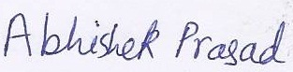
I hereby declare that the information given above is true and correct.
DATE: 18-07-2017 SIGNATURE:

TRAINING AND PLACEMENT CELL
Contact No: 0343- 2546753 Fax: 0343 - 2546753
0343 - 2752230
0343 - 2752228
URL: http://www.nitdgp.ac.in E-mail: placementcell@admin.nitdgp.ac.in

